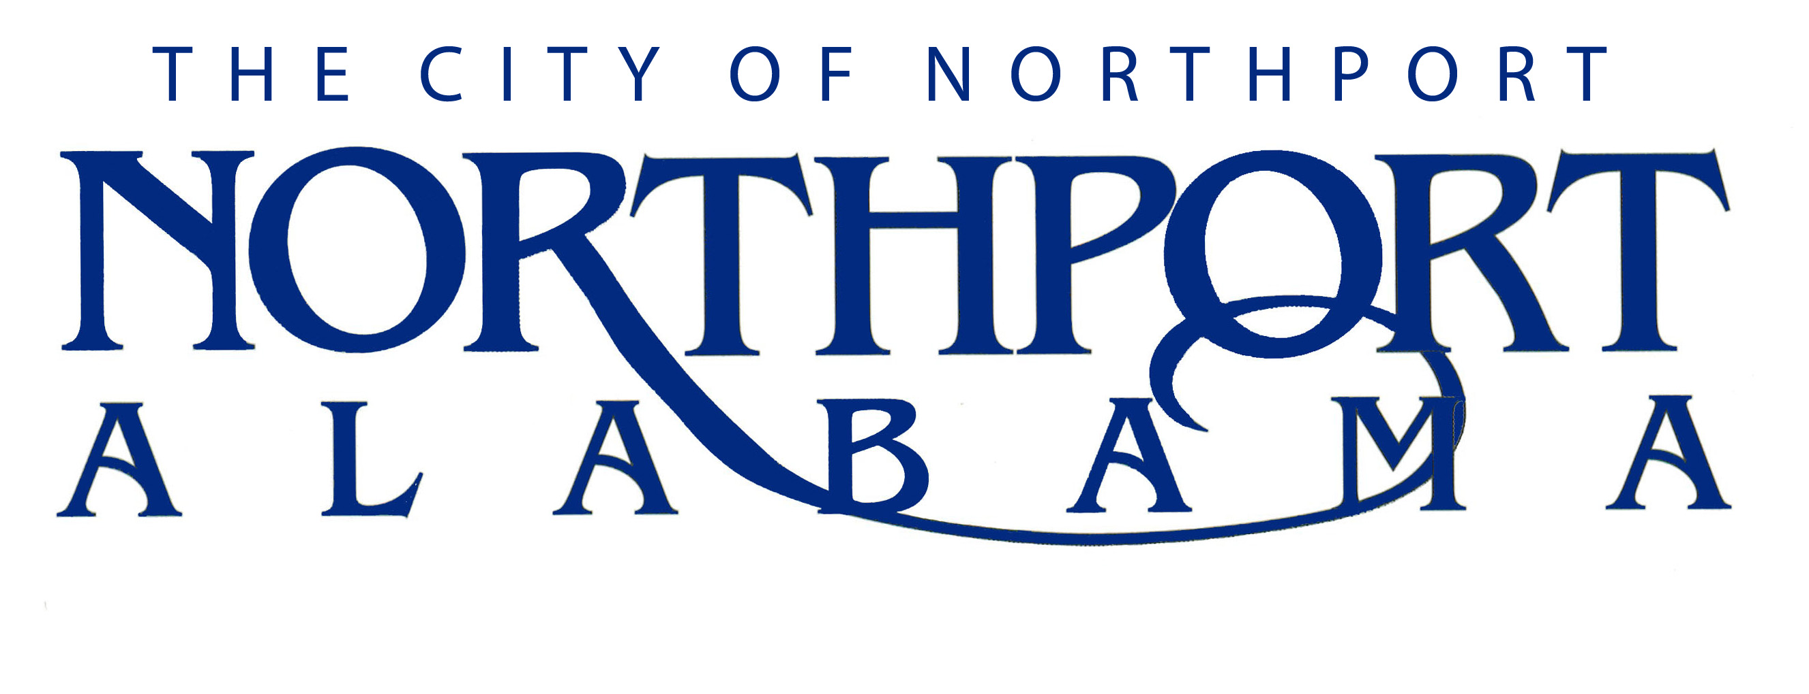
City of Northport
P.O. Box 569
3500 McFarland Blvd.
Northport, AL 35476
Job Announcement

Job Title: City Administrator

Closing Date: Monday, March 6th, 2017 @ 4:00 p.m.
If mailed must be postmarked by Friday, March 3rd , 2017

Turn in application to:
Director of Human Resources
P.O. Box 569
3500 McFarland Blvd.
Northport, AL 35476
Summary:
Responsible for the day to day administrative operations of the City and its departments. The powers and responsibilities of the City Administrator are those specifically set out by the City Council and the ultimate responsibility for the operation of the City is vested with its elected officials. Serves as Treasurer.

Salary:
FLSA Status: Exempt
Contract Position – Salary Dependent on Experience.
Salary Range $130,000-$160,000 annually

Applications may be obtained from the City of Northport Receptionist or by visiting the City of Northport website, www.cityofnorthport.org. Please see job description for all requirements and qualifications. No phone calls please!

Drug screen and appropriate background checks required prior to employment
The City of Northport is proud to be a “Drug Free Workplace”.
The City of Northport is an Equal Employment Opportunity Employer.

